Chapter 3
The global system that contains most of the life on Earth is? Biosphere
The concentrations of gases in the atmosphere that trap heat produce? Greenhouse gas effect climate change
Where would organisms that obtain energy through chemicals live? Where there is no sunlight; volcanos, ocean floors, inside other organisms
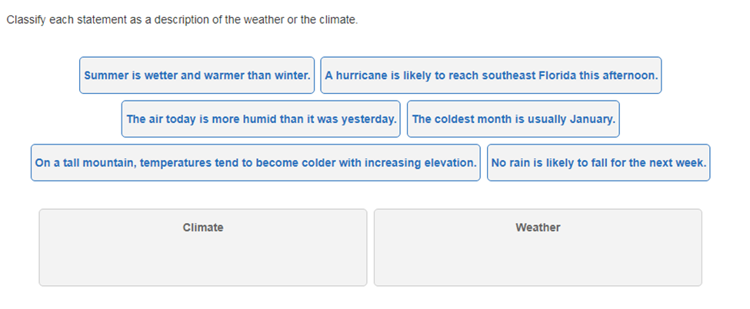
Chapter 4
What tropic level has the most available energy? Primary Producers have 100%
Classify each as a herbivore, carnivore, omnivore, or detritivore:
- An earthworm that eats the decaying remains of plants and animals : detrivore
- A bear that feeds on plants and animals : omnivore
- A cow that feeds on plants only : herbivore
- An owl that feeds on animals only : Carnivore
The series of steps in which a large fish eats a small fish that has eaten algae is a food chain or web? A food chain linear model
Which group of organisms is always found at the base of a food chain or web? Primary producers
How do nutrients move through an ecosystem? Biogeochemical cycles
Describe three ways carbon is stored on Earth. Ocean, sedimentary rock, fossil fuels, plants, atmosphere
The three main gases that trap heat in Earth's atmosphere are , methane, and water vapor. They contribute to the effect, which makes Earth's temperatures warmer than they would be otherwise.

Chapter 5
What type of population growth would you expect to see in bacteria? Exponential
How do you calculate population density? Mass/Volume
What happens if a population grows larger than its carrying capacity? Population crash
If you increase the amount of limiting nutrients in a pond how does the carrying capacity change? It will decrease the carrying capacity.

Marita is analyzing the population of various songbirds in her neighborhood. She estimates how the population is increasing by and decreasing by , as different birds enter and leave the area. She thinks that the blue jay population increased by because it doubled over a short time, but then it followed a pattern of when the population approached the . A scientist is studying a population of sharks in the Pacific Ocean. The scientist reports that compared to a few years ago, the sharks are spending less time in equatorial waters and more time in waters near California and Alaska.
Which statement describes the type of change that is occurring to the shark population?
A. Their geographic range is changing.
B. Their population density is changing.
C. Their population distribution is changing.
D. Their carrying capacity is changing.
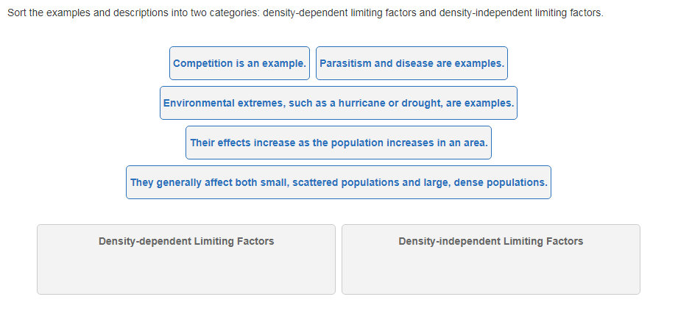

Chapter 6
What is the difference between an organism’s habitat and niche? Habitat is where the organism lives, niche is the role or job the organism holds in the ecosystem.
What affect do keystone species have on the ecosystem? They increase the biodiversity, create a bigger web of interactions, and help to create new niches, create a stable environment
Give an example of an ecosystem service and how it benefits humans.
